**Newsletter June 2024**

**ANOT May 2024**

This year the Glenelg Bridge Club had 34 representatives at the Autumn Nationals held at the Showgrounds from 2nd - 6th May. We were delighted that so many of our members took the opportunity to experience a big tournament, and with such great results.

**Congratulations to:**

**DAVID LUSK ROOKIE PAIRS**

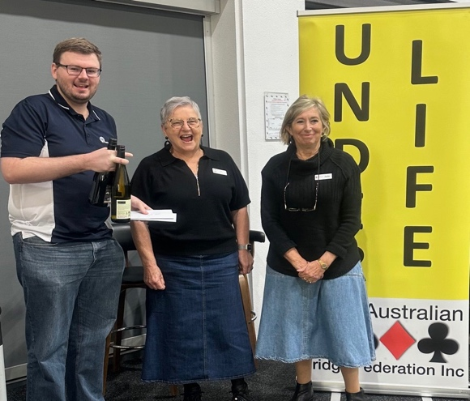5th Sharon Harris and Marvin Bunting

**STEPBRIDGE UNDER LIFE MASTER PAIRS**

1st Julie Clark – Julie Roberts !!!

3rd Kari Heikonen and Petter Carlmark

8th Gonz Uyternhove and Cynthia Brinkman

**STEPBRIDGE UNDER LIFE MASTER TEAMS**

2nd CLARK: Julie Clark – Julie Roberts, Keith Walshe – Claire Geller

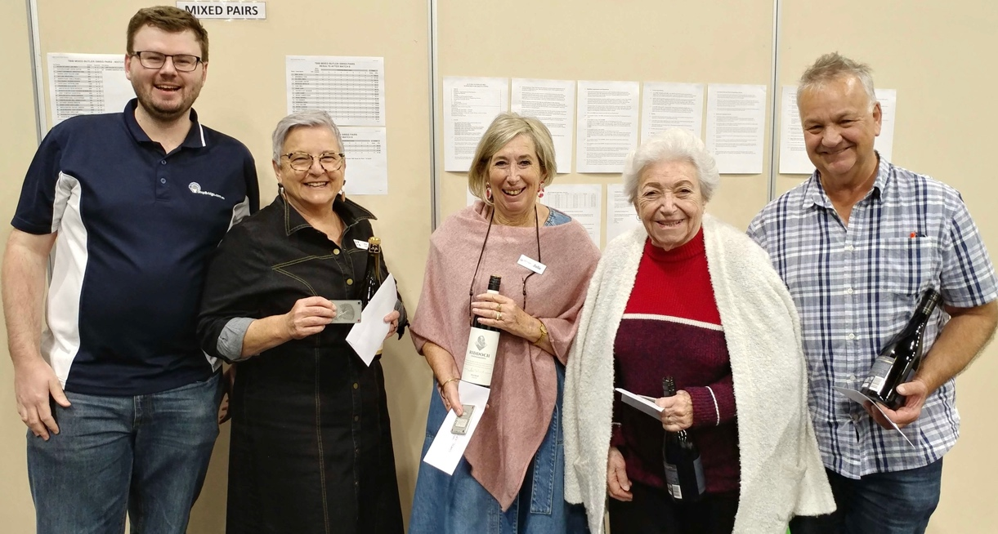

**Australia-wide Pairs Competition**

The novice (under 100mp) event was held on Thursday 30th May, with the choice of Thursday being to encourage our enthusiastic supervised players to participate in the event. Graeme Hammond, the Director, did a fantastic job of organizing and running the event. There were many positive comments about the atmosphere and vibe at the club. The tables were divided into 2 sections and a very enjoyable day was had by all. The first and second place-getters by sections were Elizabeth and Richard NS and Lyn and Ros EW– pink section, and Clayton and Shaun N-S and Jack and Warwick E-W – blue section

|  |  |
| --- | --- |
|  |  |
|  | |

Best pair, nationwide, from the club were: Elizabeth Egan & Richard Sellers 48th nationally – Well Done!

You can look up further results on the internet, [www.australiawidepairs.com](http://www.australiawidepairs.com)

**CLUB GNOT PLAYOFF**

**SATURDAY JUNE 29 2024**

**This is club members’ opportunity to earn Gold Masterpoints.**

**Organise your team and email your team nomination to the secretary**[**lizby@bigpond.com**](mailto:lizby@bigpond.com)

**There will be one session of play.**

**12.30 pm to 4.30 pm**

**ENTRY FEE: $80.00 per team**

***Please pay a director for your team by the closing date***

**ENTRIES CLOSE end of session on JUNE 21, 2024**

**RULES OF ENTRY**

* **Anyone who is a financial member or a regular player at Glenelg Bridge Club can be a team entrant.**
* **If a member or partnership of an eligible team is unable to participate in the Regional Final, with the approval of the Club Committee, substitutes will be permitted providing they participated in the Club playoff event.**

**Taking Care Of Partner** (adapted from an article in the latest “Australian Bridge”)

It is not surprising that many of the top players talk about the importance of acquiring the skill of treating your partner well.

Key factors to having a supportive and harmonious partnership are having a regular bridge partner and a clear understanding of your bidding system and sticking to it.

Often, there is a ‘critical’ point in a hand where making the right decision can make the difference between making the contract or not. Your ability to make that right choice may be influenced by many factors but there is no doubt that what happened on the previous hand and how your partner reacted to it has a substantial influence.

Making the right decision is a lot easier if you are relaxed and confident that your partner is not going to make any negative or critical comments while still at the table, no matter how bad the result is. However, don’t forget to acknowledge good bidding and play from partner.

Keeping quiet during play can be quite difficult. If agreement with your partner to save post-mortems for after bridge is made, it can lead to greater partnership confidence and every player no matter what their skill level will benefit and improve results.

A suggestion is to keep a record sheet and circle and hands that you would like to discuss with your partner at the end of the session.