A HISTORY OF THE GLENELG CONTRACT BRIDGE CLUB

COMPILED FROM AVAILABLE MINUTES 1993 - 2017
AND ORAL HISTORIES

by June & Graeme Hammond 2017
updated 2019, 2022

History

There is evidence of a bridge club at the Glenelg Town Hall called the Goodwill Bridge Club as early as 1952 (see appendix 1) who used to meet in the Community Room every Wednesday evening. They continued to hold their Bridge parties into the 60’s raising money which was donated to various charities.

The Glenelg Contract Bridge Club Inc. was not founded until Friday, 27th February,1970. (See appendix 2) In the early days, the club met in the Lady Mayoress’ Room, in the Glenelg Town Hall, once a week, on Friday evenings. Keith Berry and Norman Newland were instrumental in founding the club and Norman Newland was elected the first President. The two men were very keen to establish clubs in many metropolitan areas throughout Adelaide and Norman Newland went on to establish the Walkerville Bridge Club as well. Helen Luxton, who still plays from time to time at the Glenelg club, was one of the founding members of the club.

She recounts a funny story told to her by Keith Berry, who had an unusual liking for drinking sea water. But he liked it fresh, so he used to take a bucket onto Glenelg Jetty to get his daily drink. One day in 1971, he went onto the jetty and leaned out to hoist up the bucket. As he did so, the instructions for and entries to SA’s first congress at Glenelg which he was organising, fell out of the top pocket of his jacket into the sea below. In a panic, he ran back along the jetty to the beach, stripped to his long johns (it happened to be mid-winter) and in he went to retrieve his paperwork. He was spotted, the police were called and there was some explaining to be done.

After the Glenelg Town Hall there were several moves: first to the Rechabite Hall, Gordon Street, Glenelg in 1976, then to St Mary’s Hall, part of St Mary’s Primary School, High Street, Glenelg for a short time. By the 1977 the Club was in Partridge House, Partridge Street, Glenelg where it stayed for many years. The games were held in several of the rooms and it was felt that it would be better to have everyone together.
In May,1997, the Club moved again to the Sea Rescue Squadron, with 2 sessions (Mon & Fri) still being played at Holdfast Bay Yacht Club, Barcoo Road, West Beach. In Jan 1998 these 2 sessions were moved to Flambouron Hall, Fulton Street, Glenelg North and continued to be played there for several years.
Finally, in 2006, the club was playing all sessions in the comfortable, bright room of the Sea Rescue Squadron, Barcoo Road, West Beach.

Some interesting highlights taken from the Minutes:
1993 approx 350 club members (Appendix 3)
In 1994 Russell Dann designed a double sided pad to be used for silent bidding and they were used at the Glenelg Bridge Club.
1994 was the Club’s 25th Anniversary
May 1998, Marie Harnett (McMahon) started bridge lectures and they were generally well accepted and it was decided to advertise in the Messenger to attract new players from outside the club.
1999 Marie Harnett (McMahon) became the first person to have Glenelg Bridge Club as their home club to become a Grand Master.
2003 Kevin Battersby became a Grand Master
2005 Member numbers: 251 financial, of whom 194 were home club members, 6 Life Members
2006 Member numbers: 245 financial, of whom 196 were home club members.
The team of G & J Quinn and J & D White came 2nd in the Regional GNOT finals
2007 The team of J Kleeman, Kevin Battersby (cpt), Obbie Rieziger and Kevin Clapp came 1st in the Regional GNOT finals
2008 In June, former president and long time club member, Kevin Clapp passed away
2009 Kevin Clapp Memorial Trophy donated by Keith Walshe was instigated
2019 Club’s 50th anniversary
2011 Audrey Woods, Founder Member passed away 27 Jan
2013 144 members
2017 182 members
2019 216 members

Club Presidents:
Norman Newland | 1970 - | Tony Souter | 2009
Wally Wood |  | Peter Teubner | 2010-2013
Keith Berry |  | Arthur Porter Jnr | 2014 -2018
Frank Coyle |  | Graeme Hammond | 2019 -
Alf Gillingham | 1977
John Huston
Colin Faehse | 1987 - 1996 ( 10 years
Russell Dann | 1977
Kevin Clapp | 1998 - 2007 (9 years)
Graeme Quinn | 2008 (7months)
Alma Gallagher | 2008 (5 months)

Life Members

Colin Faehse 1994
Russell Dann 1995 | Obbie Reiziger 2011
John Huston 1999 | Tony Souter 2011
Kay Weeks 1999 | Patricia Dinan 2011
Marie Davies | Marie McMahon 2011
Audrey Wood | Iris Hughes 2013
Kevin Battersby 2007 | Arthur Porter (Jnr) 2013
Josephine Lock 2009 | Peter Teubner 2015
William Lock 2009 | Peter Williams 2018
Alma Gallagher | Helen Wetherell and Judy Maloney 2020
Arthur and Audrey Porter 2001 | Graham and Judy Quinn 2022
Kevin Clapp 2002
William Lock 2009

Annual Prizes
Tuesday Championship
1993 M Stewart & J Riley
1994 J Hood & J Matthews
1995 M Martin & M Harnett
Wednesday Championship
1993 C Faehse & J Huston
1994 K Weeks & M Clapp
1995 M Clapp & K Clapp
Thursday Championship
1993 Audrey & Arthur Porter
1994 D Shilling & J Jackson
1995 J Kleeman & K Battersby

phased out in 1995

Trophy Winners
The trophies that the club presents at the AGM each year for the previous 12 months:

K. T. Berry Trophy - earned the greatest number of masterpoints in the previous year

1993 John Huston | 2010 Dulcie Easley
1994 John Huston | 2011 June Kleeman
1995 Michael Clapp | 2012 Marie McMahon
1996 Michael Clapp | 2013 Marie McMahon
1997 Michael Clapp | 2014 - 2023 Judy Maloney
1998 Kevin Clapp
1999 John Huston
2000 Obbie Reiziger
2001 Obbie Reiziger
2002 Obbie Reiziger
2003 Kevin Battersby
2004 Kevin Battersby
2005 John Huston
2006 Kevin Battersby
2007 Kevin Battersby
2008 Marie McMahon
2009 Marie Mcmahon

Wally Wood Award - earned the greatest number of masterpoints (female)

1994 S Logie | 2007 Iris Hughes
1995 Alessandra Logie | 2008 Iris Hughes
1996 A Schultz | 2009 June Kleeman
1997 Helen Luxton | 2010 Marie McMahon
1998 Kathleen Job | 2011 Judy Maloney
1999 June Kleeman | 2012 Iris Hughes
2000 June Kleeman | 2013 Iris Hughes (deceased)
2001 June Kleeman | 2014 June Kleeman
2002 Doreen Tomlin | 2015 June Kleeman
2003 Doreen Tomlin | discontinued in favour of encouragement award
2004 Doreen Tomlin
2005 Doreen Tomlin
2006 Doreen Tomlin

Wally Wood Award - beginners encouragement award (to the player with less than 5 mpt’s at beginning of year)
(criteria changed 2016)

2017 John Abbey ( inaugural winner)
2018 Jeff Searle
2019 Helen Fehlberg
2020Jack Chyer
2021 Michelle O Regan
2022Yvonne Armstrong
20223Voytek Wielgosch
Kevin Clapp Memorial Trophy - outstanding service to the club
2009 Kay Weeks (inaugural winner)
2010 Tony Souter
2011 Helen Mander
2012 Arthur Porter Jnr
2013 Bill Jensen
2014 Kay Crossan
2015 Jenny Artis
2016 Bill Jensen
2017 Bill Jensen
2018J udith Blackstone
2019 Judith Blackstone
2020 Julie Clark
2021 Bill Jensen
2022 Joy Giles
2023 Patricia Sharpe

Patron’s Trophy - ranking of regional * or less, most improved

2008 Judy Maloney (presented by Duncan McFetridge)
2009 Keith Walshe (presented by Duncan McFetridge)
2010 Eddie Skala (presented by Ms Kate Cunningham on behalf of
D McFetridge)
2011 Ramon Walton ( presented by Peter Teubner, President)
2012 Trevor Oliver
2013 George Lupul
2014 Peter Hayles (presented by Duncan McFetridge
2015 Claire DeLambert (presented by Duncan McFetridge)
2017 Julie Clarke (presented by Duncan McFetridge)
2018 Josie Cock (presented by Duncan McFetridge)
2019 Josie Cock (presented by Stephen Patterson)
2020 John Abbey (presented by Stephen Patterson)
2021 Julie Roberts (presented by Stephen Patterson)
2022 Julie Roberts ( presented by Graham Quinn)
2023 Andrea Dayman (presented by Stephen Patterson)

Student of the Year Award
2016 Ross Grantham (inaugural winner)
2017 Ruth Summers
2018 Jon Parrington
2019 Richard Triggs
2020 discontinued

Spring Congresses at Glenelg
1998 Flambouron Hall | David Anderson. | M & K Clapp
1999 Flambouron Hall | David Anderson | M & K Clapp
2000 Flambouron Hall | David Anderson | M Harnett & M Clapp
2001 Flambouron Hall | Michael Clapp | Sue Phillips & Obbie Reiziger
2002 Flambouron Hall | Michael Clapp | Sue Phillips & Obbie Reiziger
2003 Flambouron Hall | David Lusk
2004 Flambouron Hall | David Lusk
2005 Sea Rescue Squadron | Phil Gue | Geraldine Eitzen & Kevin Clapp
2006 Sea Rescue Squadron | Phil Gue
2008- 2019 Sea Rescue Squadron | David Anderson
2020 not held due to COVID
2021 not held due to COVID | David Anderson
2022 Sea Rescue Squadron | David Anderson
2023 Sea Rescue Squadron

Appendix 1
Members list 1993

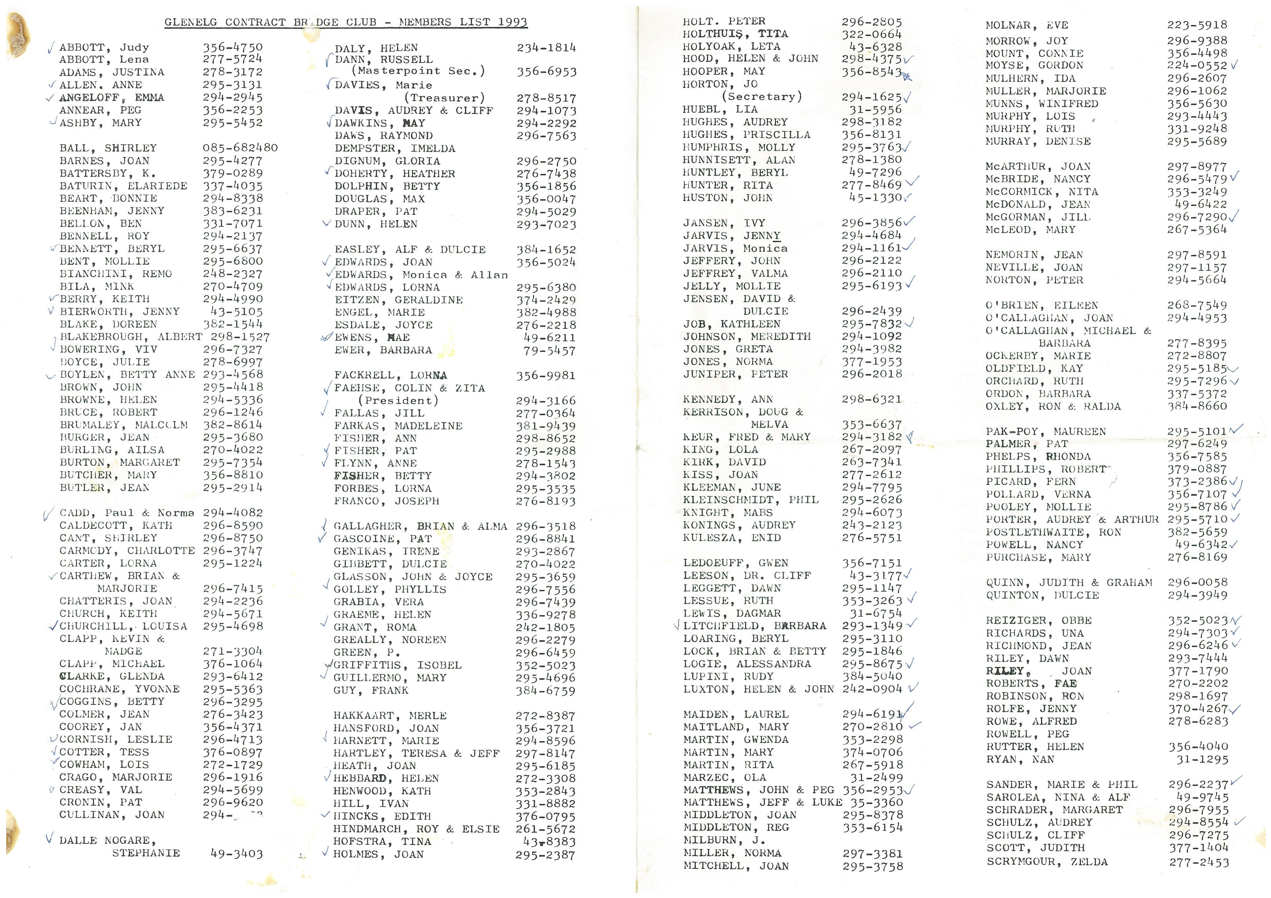
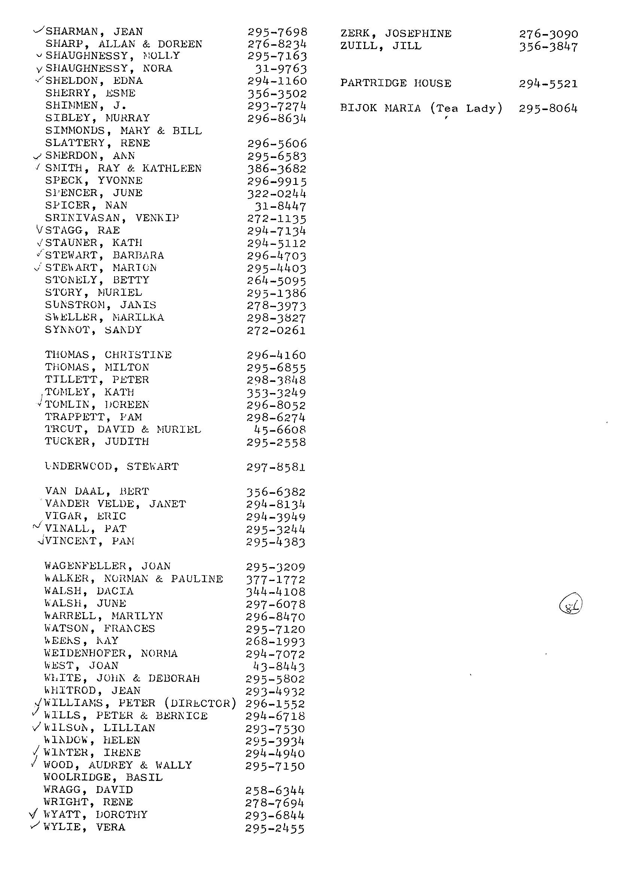
Appendix 2

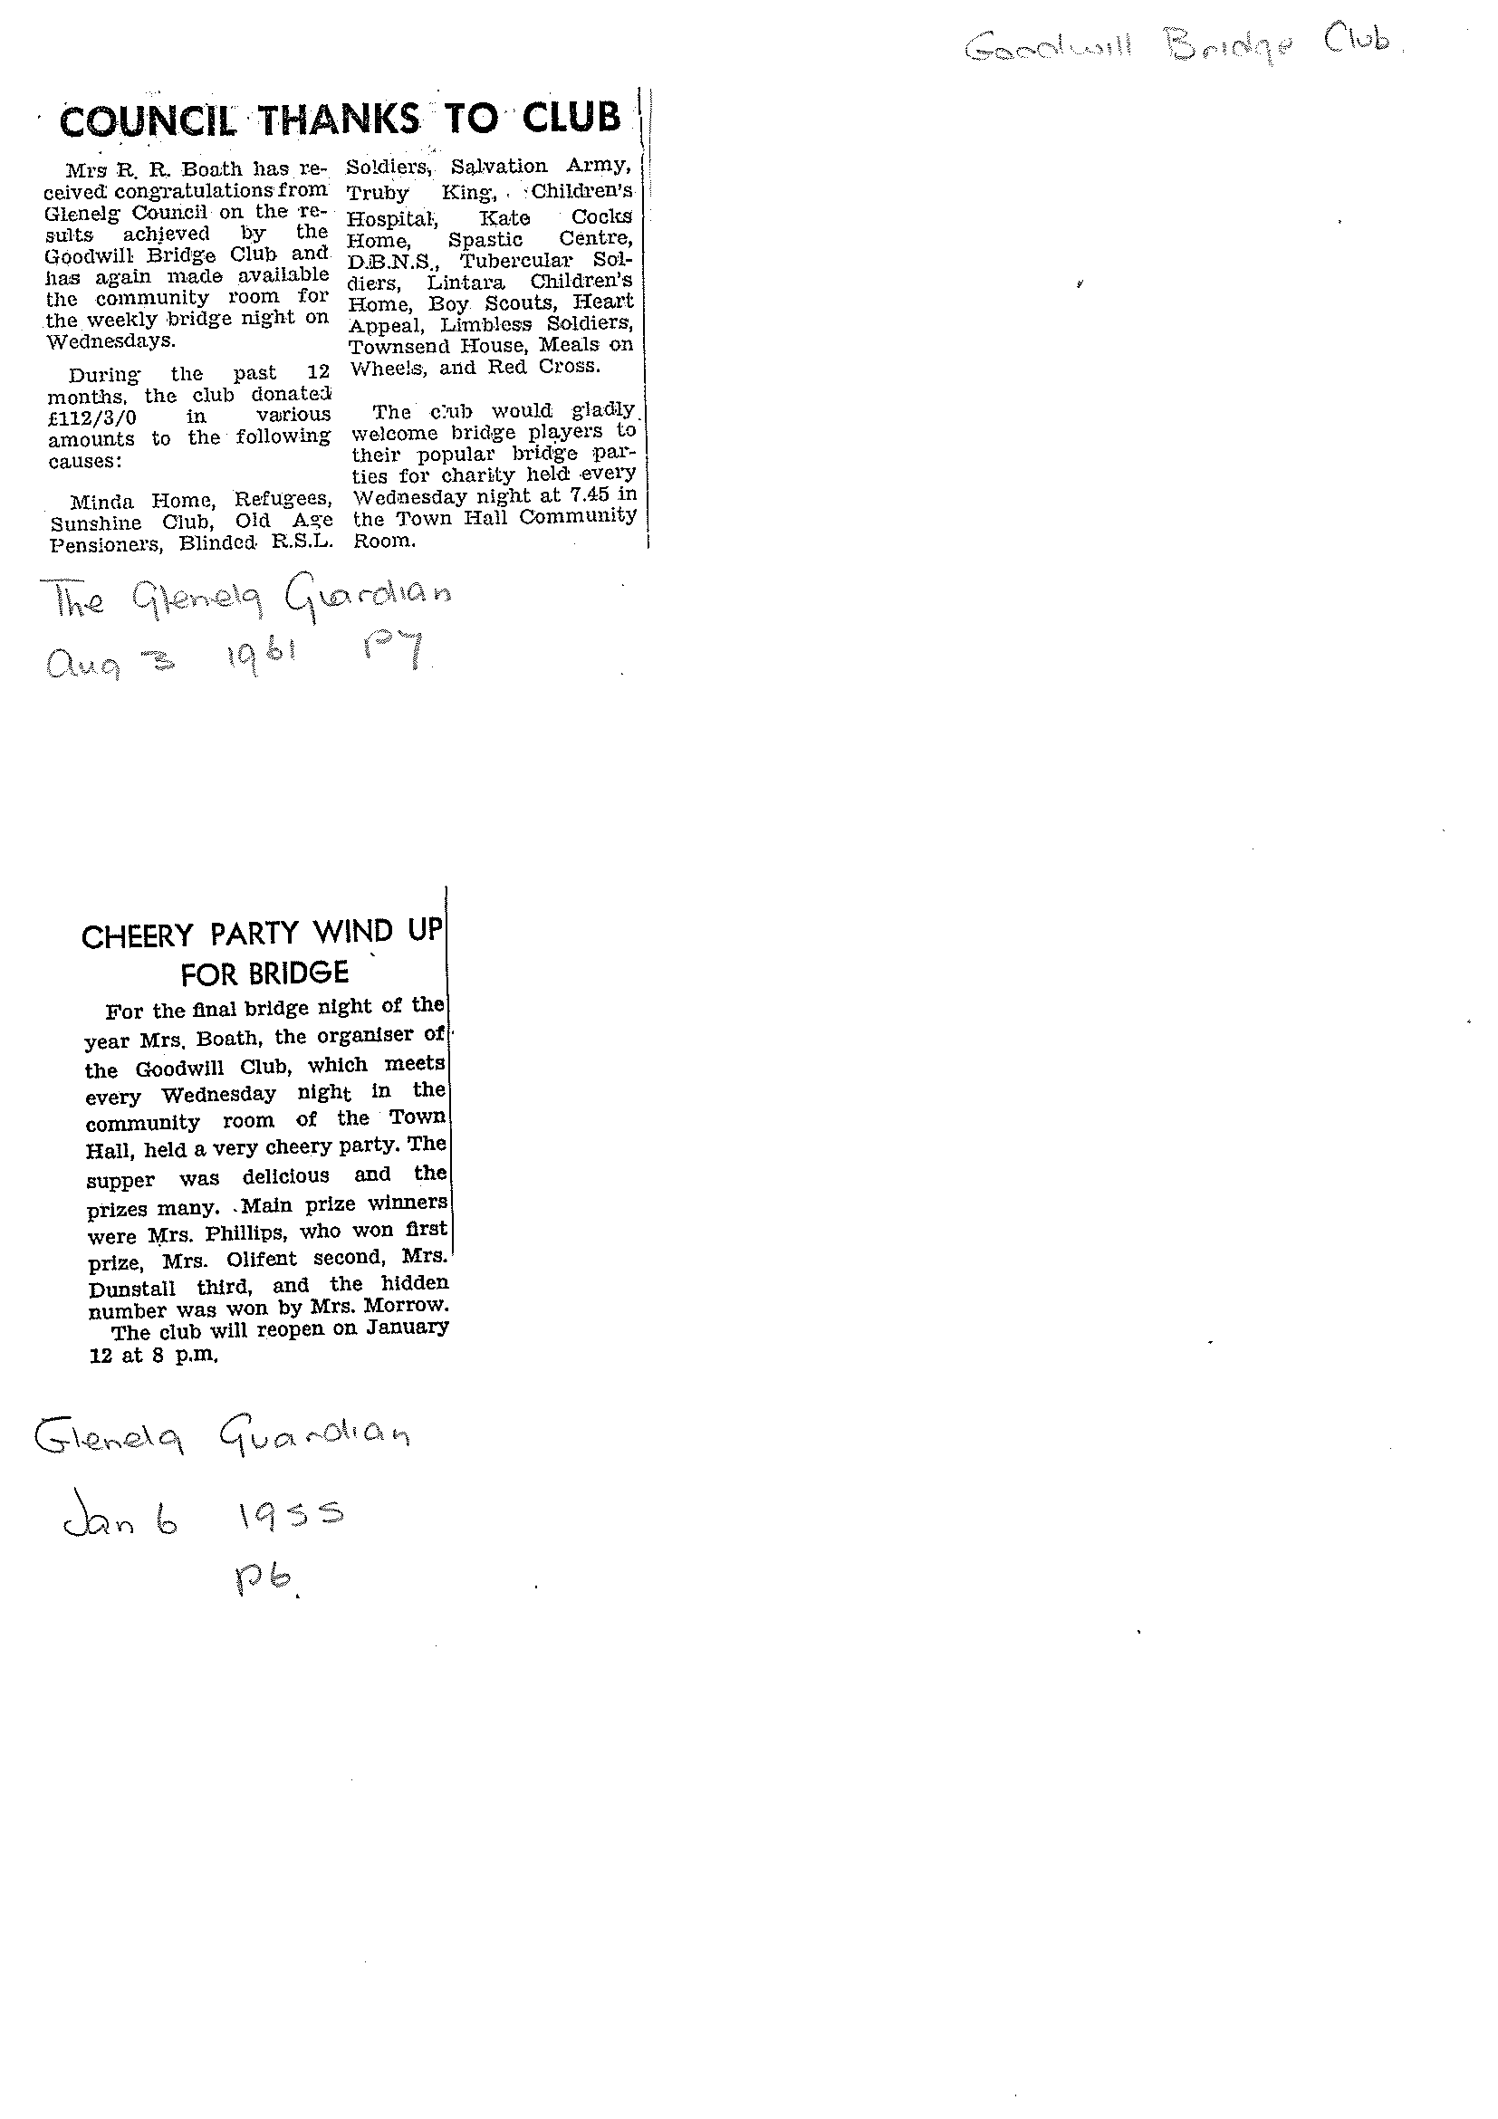

Appendix 2a

This information was found in the Minutes Book, 7/7/1993 - 8/12/1998 and is faithfully reproduced below:

Club Formation

GLENELG CONTRACT BRIDGE CLUB, INCORPORATED.
HISTORICAL NOTE

A meeting was arranged for Friday, 27 February 1970, at the Glenelg Town Hall, resulting in the club being formed. It commenced operation on the following Friday in the Community Rooms at the Town Hall.
The club continued to use the Community Rooms until 1976, when the accommodation became insufficient for the number of members. They then hired rooms at the Rechabite Hall in Gordon Street, for one night each week.
At this time the Town Hall was undergoing reconstruction, and the Glenelg Council had bought Partridge House, at 38 Partridge Street. The Town Clerk of the time, Mr R. G. Lewis, asked me (Keith Berry) for an opinion of what the club would have to say if accommodation were to be made available at Partridge House. My answer was “I think they would be most appreciative.” He then said to me, “All right, leave it to me.”
On 5 February, 1977 Wally Wood and Rick Parsons looked at Partridge House. On 11 February, 1977, the club held its Annual General Meeting and Alf Gillingham was elected President.
On Friday, 1 June 1977 the Club held its firs night’s bridge at Partridge House.

Keith Berry
These notes were compiled from personal recollections and reminders from Audrey (Mrs Wally) Wood

